**Controls**w = up  
a = down  
s = left  
d = right  
spacebar = shoot  
  
  
**Install Instructions**the solution is set up so that the projects start in the order they are supposed you have to click start debugging.  
  
  
**features**Achievements  
login (register is located in the web api authentication though on the monogame side I have attempted it at least.)  
Multiplayer on local host  
Timed announcements  
collectables  
  
NOT PRESENT  
leader bored  
Notifications  
A record of the players profile  
  
  
  
**Known Problems**  
“This project references NuGet package(s) that are missing on this computer. Enable NuGet Package Restore to download them. For more information, see http://go.microsoft.com/fwlink/?LinkID=317567.   
WebAPIAuthenticationClient   
C:\Users\user\Desktop\Repeat Exams\CusualGames\WebAPIAuthenticationClient\WebAPIAuthenticationClient.csproj”  
  
I wrestled with this for a few hours and looked up stuff online saying to remove NuGet Refernces in the csproj file but this did not slove the error I apologize for this as it does stop the game from running however, this isn’t strictly a code issue as NuGut packages are present in the web api authentication client so they are enabled and they are correct.  
  
Metadata file 'C:\Users\user\Documents\GamesCultureRepeat\GamesCultureRepeatAssignment\SingalRclient\Game2\bin\Windows\Debug\Game2.exe' could not be found   
SignalRWebClient C:\Users\user\Documents\GamesCultureRepeat\GamesCultureRepeatAssignment\SingalRclient\SignalRWebClient\CSC”  
This error I too am very stumped on I have found and located the game2.exe file (Screen shoted below) yet it says it does not exsit and there also is no such file as csc in signalrweb client folder so im not sure. Apologies for the inconveniences caused again this stops the game from running correctly as it technically counts as an error but not a code error.)   
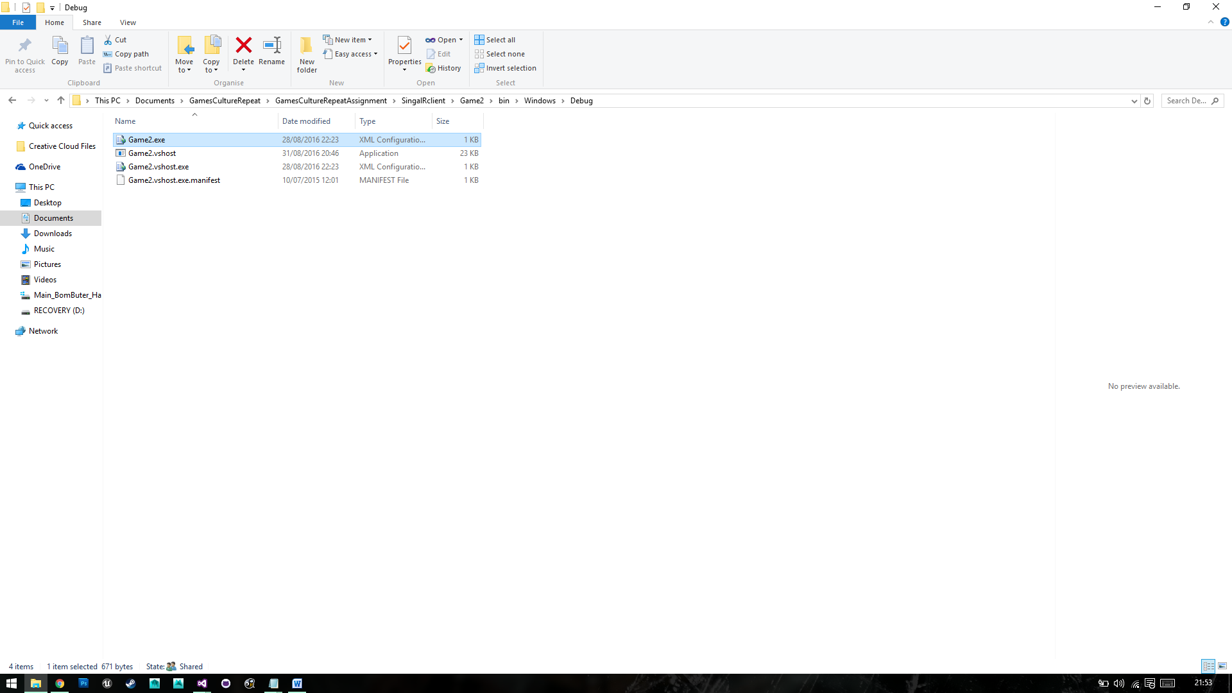  
  
  
I would also just to like out the reason for some lack of commits this is due to me being on work experience in galway until late july start of august and I had access to limited internet down there so I made a start on the project and then committed it when I had most of the basic stuff in. also this combined with other exams to repeat left me somewhat stuck for time the last week or two so sorry for any rushed code.